"Kefa and Park": A Deep Dive into Tree Traversal with DFS

This blog analyzes the approach and implementation details for solving the competitive programming problem ‘’Kefa and Park’’ (https://codeforces.com/problemset/problem/580/C)

Problem Overview:
Kefa wants to visit a restaurant located in a park represented as a tree of n vertices (nodes). Each vertex may or may not have a cat. Kefa’s mother, however, set one condition: He cannot go through more than m consecutive vertices that have cats. Kefa starts at vertex 1 (the root) and wants to visit leaf nodes (restaurants). We must find how many leaf nodes Kefa can reach without exceeding the limit of consecutive cat nodes.

Problem Breakdown:
We’re given a tree graph, so:
- There is exactly one path between any two vertices.
- We can represent it using an adjacency list.
- Starting from node 1, we explore all paths to leaves.
- We maintain a counter of consecutive cat nodes and stop exploring when the count exceeds m.
- Whenever we reach a leaf within the limit, we increase our valid restaurant count.

Technology Used:
Language: Python
Data Structures: Adjacency List (for graph), Boolean array (for tracking visited nodes).

Algorithm Choice: Depth-First Search (DFS)
We use DFS (Depth-First Search) — a fundamental AI search algorithm — to explore all paths from the root to leaves.

Why Depth-First Search (DFS)?
We are dealing with a tree, and the constraint is path-dependent (from root to leaf). Depth-First Search (DFS) is the ideal choice here because it naturally explores paths fully from the root to the leaves.
DFS is ideal for this problem because:
- It explores complete paths recursively before backtracking.
- It naturally fits tree traversal.
- We can easily carry and reset the “consecutive cats” count as we move along the path.

Advantages & Uses of DFS:
- Space Efficiency: In trees or sparse graphs, DFS generally requires less memory than Breadth-First Search (BFS) as it doesn't need to store all nodes at the same level (like BFS).
- Path Finding: It's inherently suited for tasks involving paths, such as finding a path, checking connectivity, or, in this case, validating paths based on a cumulative property.
- Topological Sorting: Used for ordering tasks with dependencies.
- Cycle Detection: Easily implemented by checking for back edges.
- Tree Traversal: The most standard and efficient way to explore every node and edge in a tree.
- Pruning: DFS naturally supports early pruning (stopping the exploration of a path) as soon as a constraint is violated, which significantly improves performance.

Code Implementation:
import sys
sys.setrecursionlimit(2000000)
input = sys.stdin.readline

n, m = map(int, input().split())
cats = list(map(int, input().split()))
adj = [[] for _ in range(n)]

# Read EXACTLY n-1 edges (so no waiting for more input)
for _ in range(n - 1):
u, v = map(int, input().split())
u -= 1
v -= 1
adj[u].append(v)
adj[v].append(u)
visited = [False] * n
ans = 0
def dfs(u, consecutive):
global ans
visited[u] = True

if cats[u] == 1:
consecutive += 1
else:
consecutive = 0

if consecutive > m:
return
leaf = True
for v in adj[u]:
if not visited[v]:
leaf = False
dfs(v, consecutive)
if leaf:
ans += 1
dfs(0, 0)
print(ans)

Example used:
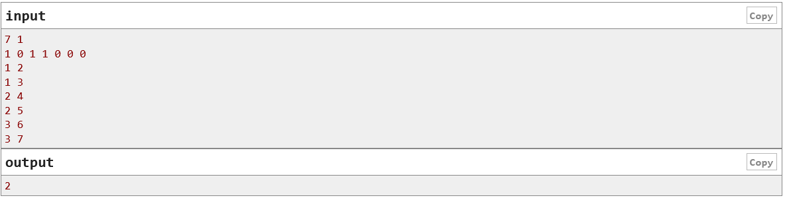

Input:

7 1
10 1 1 0 0 0
1 2
1 3
2 4
2 5
3 6
3 7

Output:
2

Execution & Analysis:

Input example:
parameter | value
n | 7
m | 1

Cats Array (0-indexed): [1, 0, 1, 1, 0, 0, 0]
Edges (1-based from input, 0-based in code): (1, 2), (1, 3), (2, 4), (2, 5), (3, 6), (3, 7)
m=1. We check the paths to the leaves (Nodes 3, 4, 5, 6 in 0-indexed):
Path to Leaf 3 (Vertex 4):
- 0→1→3.
- Nodes: Cat (1) → No Cat (0) → Cat (1).
- Consecutive Cat Count: 1→0→1. (Max is 1).
- 1<= m. VALID. Count: 1.
Path to Leaf 4 (Vertex 5):
- 0→1→4.
- Nodes: Cat (1) → No Cat (0) → No Cat (0).
- Consecutive Cat Count: 1→0→0. (Max is 1).
- 1<= m. VALID. Count: 2.
Path to Leaf 5 (Vertex 6):
- 0→2→5.
- Nodes: Cat (1) → Cat (1) → No Cat (0).
- Consecutive Cat Count: 1→2.
- 2> m =1. INVALID. Path is pruned at node 2.
Path to Leaf 6 (Vertex 7):
- 0→2→6.
- Nodes: Cat (1) → Cat (1) → No Cat (0).
- Consecutive Cat Count: 1→2.
- 2> m =1. INVALID. Path is pruned at node 2.

Output
The final count of reachable restaurants is 2.

Step-by-Step Explanation:
The solution relies on a single DFS function that simultaneously builds the path, checks the constraint, and counts the results.
Step | Functionality | Code logic | Explanation
Initialization | Set up the graph and global variables | adj = […], ans = 0, visited = […] | We use an Adjacency List to handle graph connections and a visited array to prevent traversing backward to the parent in the tree, which is crucial for treating the tree as rooted during traversal.
DFS State | The state passed in the recursive call | dfs(u, consecutive) | ‘u’ is the current node. consecutive is the count of consecutive cat nodes encountered on the path ending at node u.
Update Count | Determine the new consecutive count based on node u | if cats[u] == 1: consecutive += 1 else: consecutive = 0 | If the current node has a cat, the count increases. If it does not have a cat, the consecutive streak is broken, and the count resets to 0.
Pruning | Implement the constraint check early | if consecutive > m:  return | This is the key optimization. If the current path already violates the maximum allowed consecutive cat count (m), we immediately stop exploring any child paths from u and return.
Leaf check | Identify and count valid restaurants | leaf = True... for v in adj[u]... if not visited[v]: leaf = False... if leaf: ans += 1 | A node u is considered a leaf in the context of the traversal if all its neighbors have already been visited (meaning its only unvisited neighbors are its children, and if there are none, it's a leaf). If a node is a leaf and the traversal reached it without being pruned, we increment the global counter ans.
Recursive call | Continue the path exploration | dfs(v, consecutive) | For every unvisited neighbor (which represents a child node), we recursively call DFS, passing the new calculated consecutive count.

Complexity Analysis:

Metric | Analysis | Complexity
Time Complexity | The algorithm is a standard DFS traversal on a graph with N vertices and N−1 edges (a tree). Every vertex is visited exactly once, and every edge is checked exactly twice (once from u to v, and once from v to u during initialization) | O(N)
Space Complexity | This includes space for the Adjacency List (edges), the cats array, the visited array, and the recursion stack. For a tree, the adjacency list is O(N), and the stack depth is at most O(N) | O(N)

The linear time complexity O(N) is highly efficient, making this solution suitable for the given constraint of N<=10^5.

Conclusion:

The "Kefa and Park" problem is a classic example of applying Depth-First Search (DFS) on a tree with a path constraint. By using the recursive nature of DFS, we are able to efficiently track the state of consecutive cat vertices along any path from the root. The key to the O(N) solution is the effective use of pruning (stopping exploration of paths where consecutive > m) combined with the correct identification of leaf nodes to ensure only valid restaurants are counted.

Blog Team Members:
- Faria Khanam Jerin (https://github.com/FariaJerin)
Id: 0432320005101002
- Zearin Akhter (https://github.com/Zearin14)
Id: 0432320005101014
- Fatema Akter Lamia (https://github.com/lamu107)
Id: 0432320005101015

